Press
16.04.2020

cirp GmbH
Service provider for the production
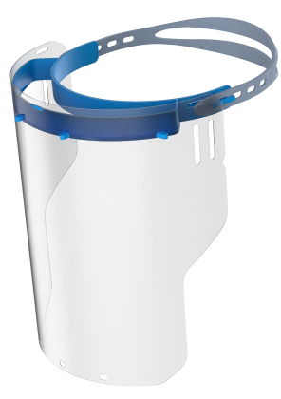of prototypes and small-run series
cirp and Fazua develop a reusable face shield

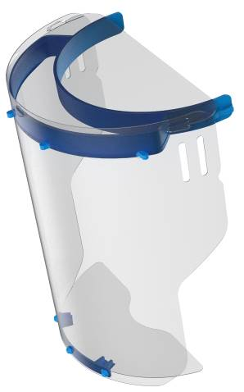The company cirp GmbH, a specialist for additive manufacturing and rapid tooling in Heimsheim, Baden-Wuerttemberg and Fazua GmbH, manufacturer of electric bicycle drives in Ottobrunn, Bavaria, have produced together a face shield as respond to the current situation. The face shield was created in record time as joint development in close cooperation with clinics in Munich, Rosenheim and Oldenburg. It stands out because of its stable frame, a large side cover and a high wearing comfort. A large number of face shields can be ordered straight away.
The face shield developed by cirp and Fazua can be expanded for specific applications using additional chin and forehead flaps.
Thomas Lück, Innovation and Sales Manager at cirp GmbH, Heimsheim, hands over the face shields’ first 800 forehead bands to Johannes Biechele, Managing Director at Fazua GmbH, Ottobrunn
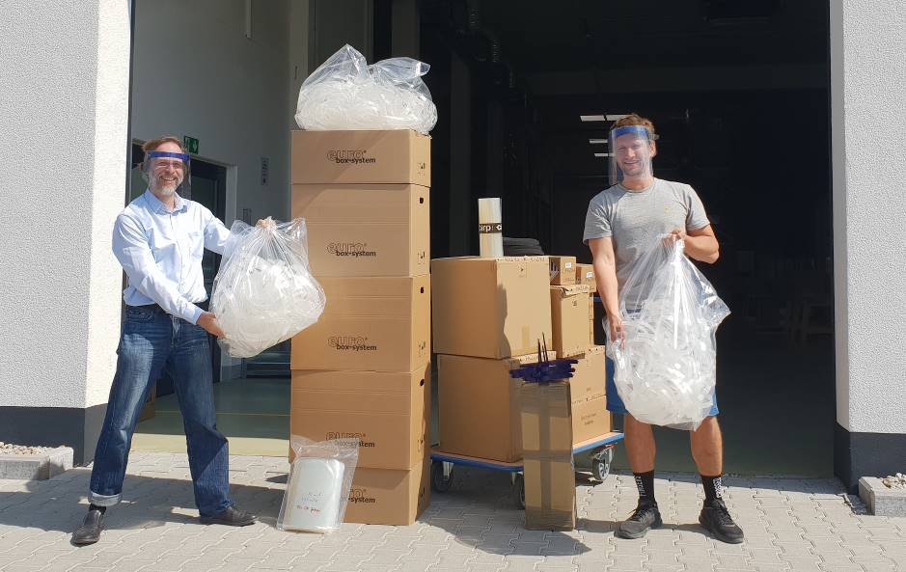
For many years, cirp and Fazua have engaged in a trusting cooperation when it comes to quickly supplying plastic parts ready to be tested for bicycle drives and to bringing them into series production. So far, the production of medical supplies was not part of their collaboration. However, both companies recently received several inquiries from medical centers desperately looking for equipment for their employees, specially face shields.

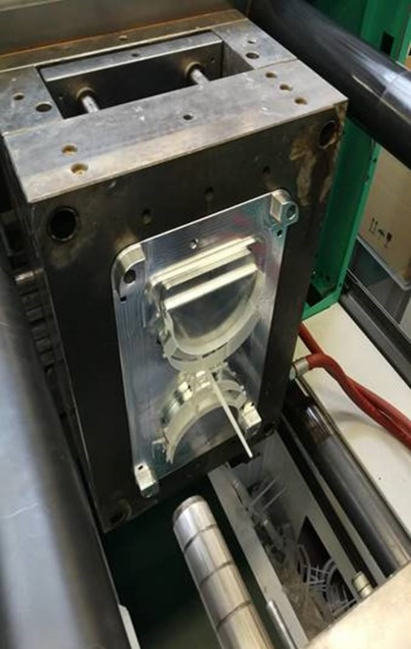
The companies used this demand as a reason to work together designing and manufacturing a face shield. “In the past, we have always been deeply impressed by cirp on how they delivered tools and components within days”, commented Johannes Biechele, managing director at Fazua. “That is the reason why we discussed with the experts in Heimsheim right at the outset if we’d be able to produce the necessary amount using 3D printing or rather injection moulding machines”. Currently there are already many initiatives to produce 3D-printed face shields Europe-wide. In the case of cirp and Fazua, 3D printing served a key development tool. However, it was clear to them that for the main component of the visor, 3D printing was a too slow a process as to meet the acute demand within short period of time. That is why the partners designed a solution to manufacture the forehead band using injection moulding.

Less than four days went by from the initial draft to the first 800 forehead bands. That is truly remarkable, considering that the production of the injection moulds alone already takes a few weeks. The draft version was ready on a Monday morning and the 3D-printed prototype was approved in the afternoon. The following day, cirp created a mould that was used to produce the first 800 forehead bands on Thursday. Johannes Biechele certainly received the delivery on Friday. Simultaneously, Fazua had already produced the matching visors, an on that same day, Fazua supplied the first medical center.
For the forehead band of the face shield developed in collaboration with Fazua, cirp created an injection mould in just 2 days.

This is how cirp and Fazua are helping

One of the main characteristics of the face shield is that it completely covers the sides of the face. Additionally, flaps to cover the chin and the forehead can be purchase separately as accessory. This particular design was developed in collaboration with and according to the indications given by a medical center in Munich, the RoMed Clinic Rosenheim, and Prof. Dr. med Dirk Weyhe, director of the Clinic for General and Visceral Surgery, University Clinic for Visceral Surgery at Pius-Hospital Oldenburg, Medical Campus University Oldenburg.

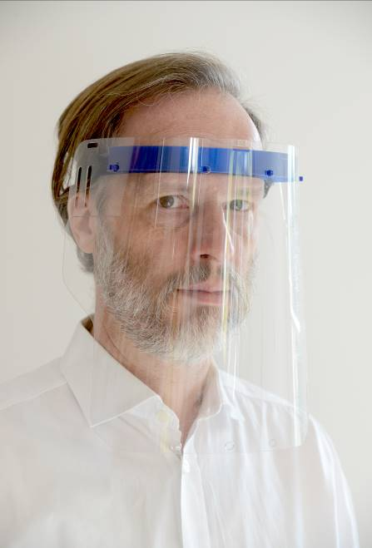 The face shield is reusable since it can be easily cleaned with common disinfectants. The stable visor with dimensions 340 mm x 255 mm offers a wide protection of the face without restricting too much the movements of the wearer. The distance between the visor and the forehead band is 4 cm. so it can be worn over masks, goggles and/or glasses. Additional flaps can be attached to the chin and forehead offering extended protection against splashes. The low total weight (97 g) ensures maximum wearer comfort. The responsibility for proper use lies hitherto with the wearer or employer. The partners are seeking approval for medical use.
The face shield from cirp and Fazua was developed in record time and its stability, reusability and high wearing comfort make it stand out.

Laser sintering is the powder bed-based 3D printing process used by cirp to produce the small chin flap. To manufacture this and other similar products, EOS GmbH, a company in Krailling, Bavaria, has supported cirp’s activities by providing PA2200 powder for the 3D printing process. Material supply for relevant COVID-19 products is bound to special terms to counteract the current healthcare supply shortage. “We are very glad that our longstanding partner EOS has demonstrated its unbureaucratic solidarity towards our activities,” commented Ralf Nachreiner, managing director at cirp GmbH. “I am very proud on how fast and closely we are currently collaborating with clients, suppliers and scientific institutions to provide items that until now were not part of our core business”, he added.

Several thousand face shields can be manufacture daily with immediate effect. Packaging units containing 100 items are available at cirp and Fazua. With their commitment, both companies want to make a contribution towards the healthcare system given the current circumstances and are simultaneously addressing other requests from what nowadays has become a particularly decisive sector.

For more information visit cirp.de

About cirp GmbH
Since 1994, cirp GmbH produces models, prototypes and small-run series in plastic using therefore generative procedures such as stereolithography, selective laser sintering or PolyJet. Equipped with CNC processing centers and the latest injection molding machines with a clamping force of up to 4500 Kn, our company meets the requirement to offer test-standard pieces, and often bridge the gap before the large-scale series tool. Even before finished data is available, our design department relies on modern CAD/CAM Systems and 3D scanning technologies to help its clients. As partner in various collaborative research projects, cirp GmbH is as well committed to continuously shifting and expanding the possibilities and limits from the idea to the product. (www.cirp.de)

About Fazua GmbH
Fazua was founded in 2013 in Munich and pursues its goal of revolutionizing the eBike market. Led by managing directors Johannes Biechele and Fabian Reuter, the Fazua team has developed an innovative eBike drive system aimed at pushing the limits of cycling mobility while also preserving the natural feel of a non-motorized bike. At present, the company has over 100 employees. (www.fazua.com)

